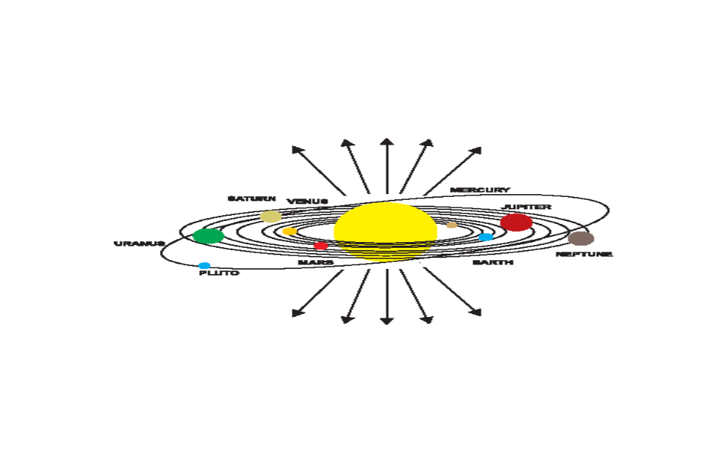 Solar Rays that Do not Fall on the Planets, the Satellites or the Asteroids

